**Details Data Set:**

This data set contains the details of all the order IDs – Amount payed for the order, profit incurred on the order, quantity per order, category and subcategory under which the items ordered fall, payment mode of the order.

**Payment mode v/s count of order ID:**

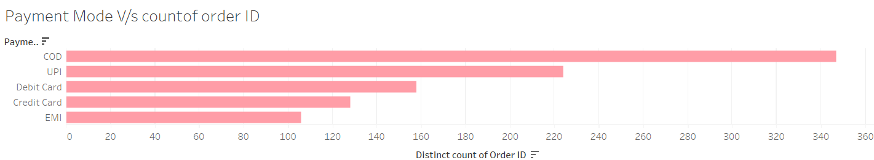

Payment for maximum number of orders has occurred through COD mode of payment.

**Sub category v/s count of order ID:**

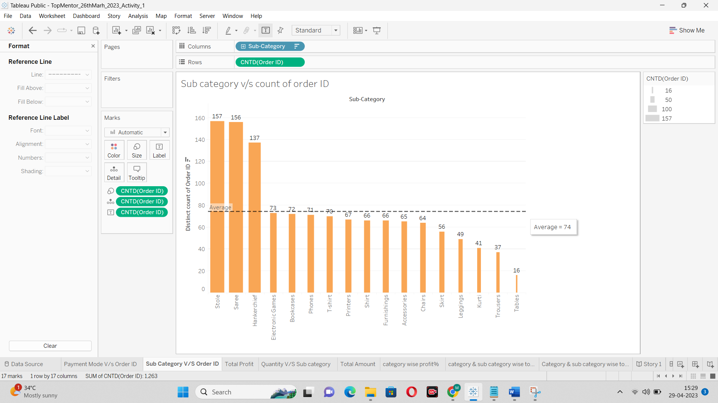

Maximum number of orders have been placed for Stole, immediately followed by Saree. Lowest number of orders have been placed for Tables. Average number of orders is 74.

**Total Quantity v/s Sub category:**

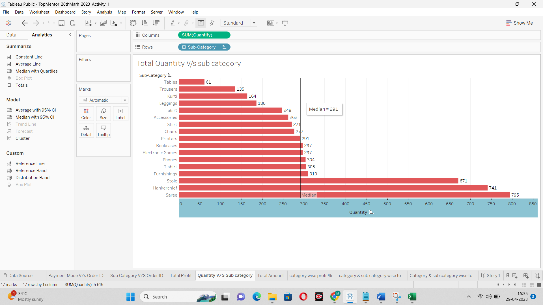

The total number of quantities ordered for Saree, Handkerchief and Stole are the highest. The median value (in terms of total quantity) of the quantity is 291

**Category wise profit%:**

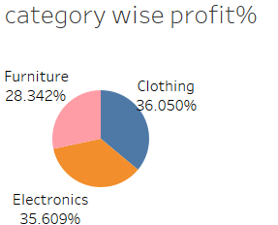

Highest profit % is for Clothing category, closely followed by Electronics category.

**Category & sub category wise total profit:**

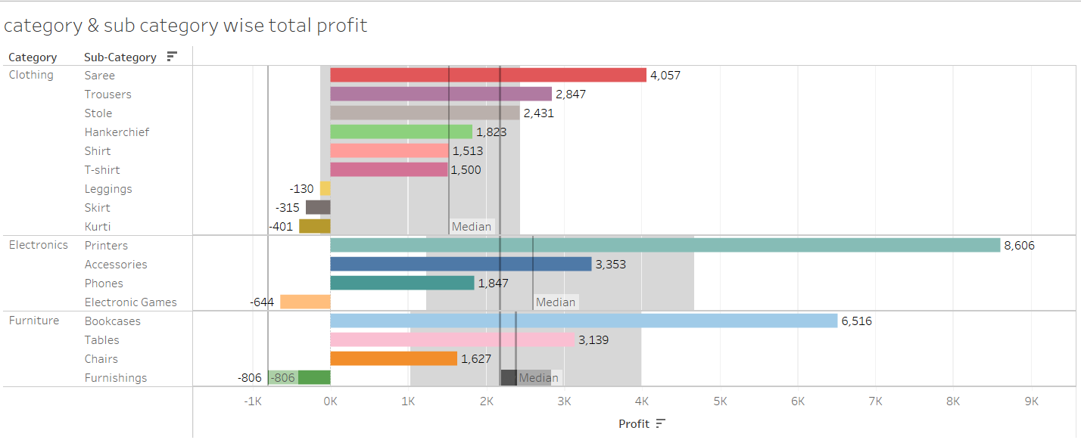

The total profit for Saree (clothing category), printers (electronic category) and Bookcases (furniture category) is highest. There are few subcategories such as leggings, Skirt, kurti (clothing category); electronic games (Electronics category); and furnishings (furniture category) that have incurred losses.

**Category & sub category wise total quantity:**

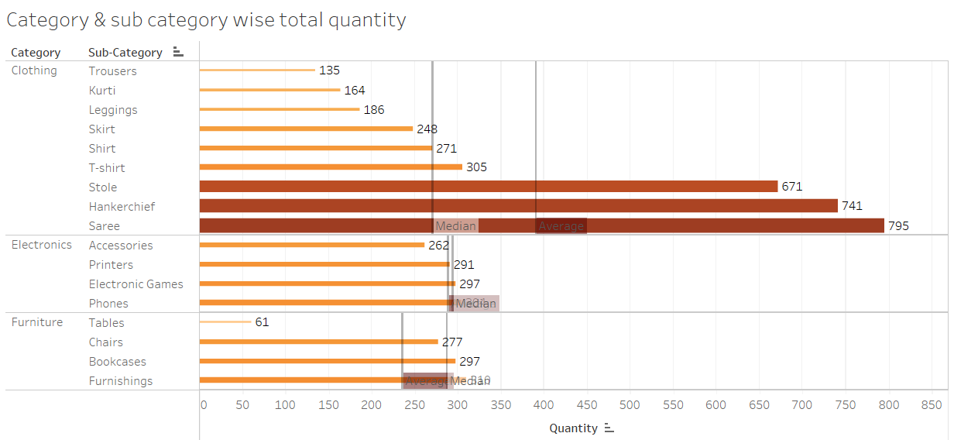

The highest quantity was sold for Saree (clothing category), phones (electronics category), and furnisihings (furniture category).

**Category/Sub category v/s Quantity:**

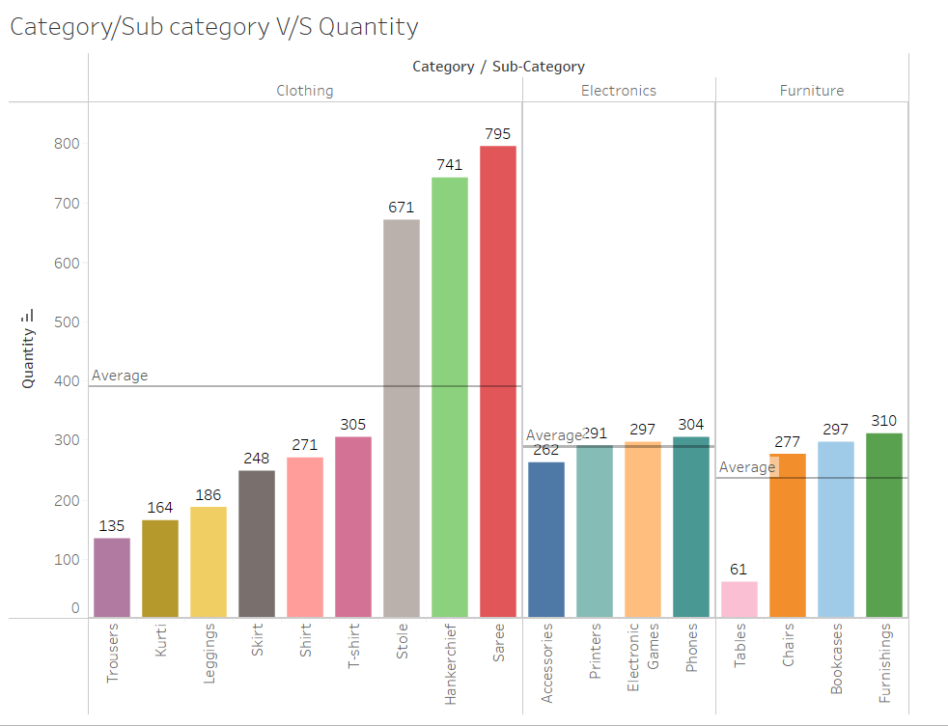

Sarees, Phones and Furnishings have the highest no. of quantity sold in each of the three categories.

**Category, Sub category v/s Quantity:**

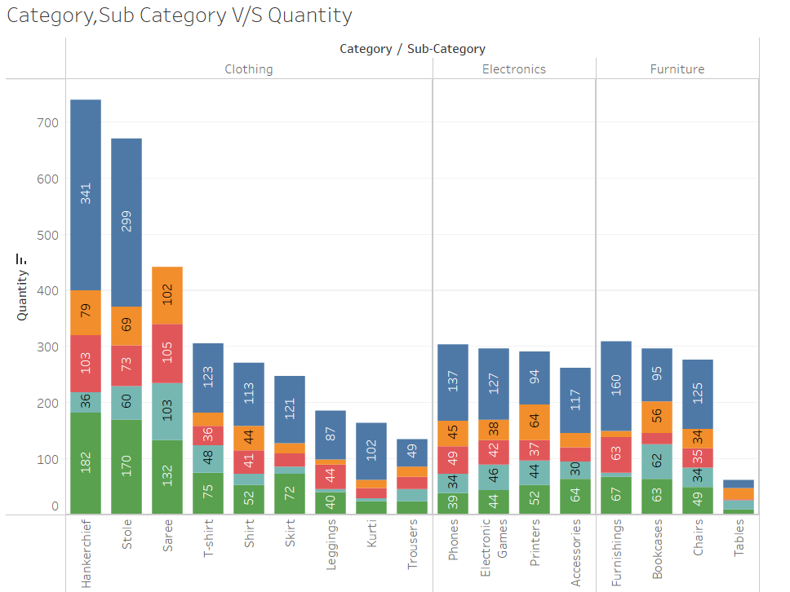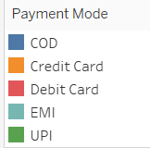

**Payment Mode v/s Amount & Profit:**

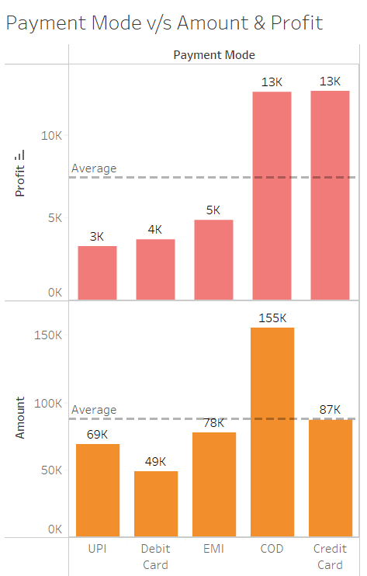

The highest profit was made through credit card payment mode but the highest amount was payed through COD payment mode.

**Main Dashboard:**

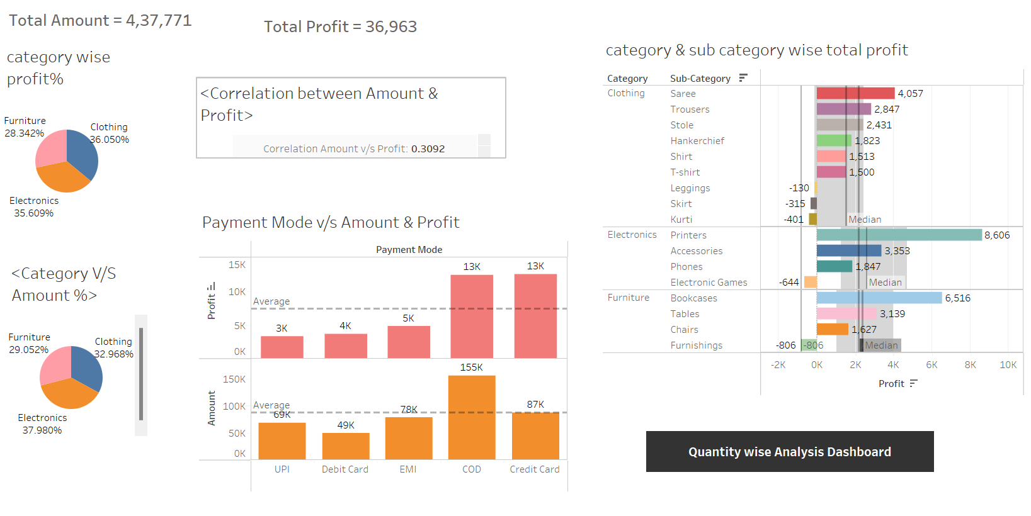

Total amount is 4,37,771 and total profit is 36,963. Correlation between Amount and Profit is extemely low. Profit% of the total is highest for clothins category. Amount% of the total, is highest for Electronics category.

**2nd Dashboard:**

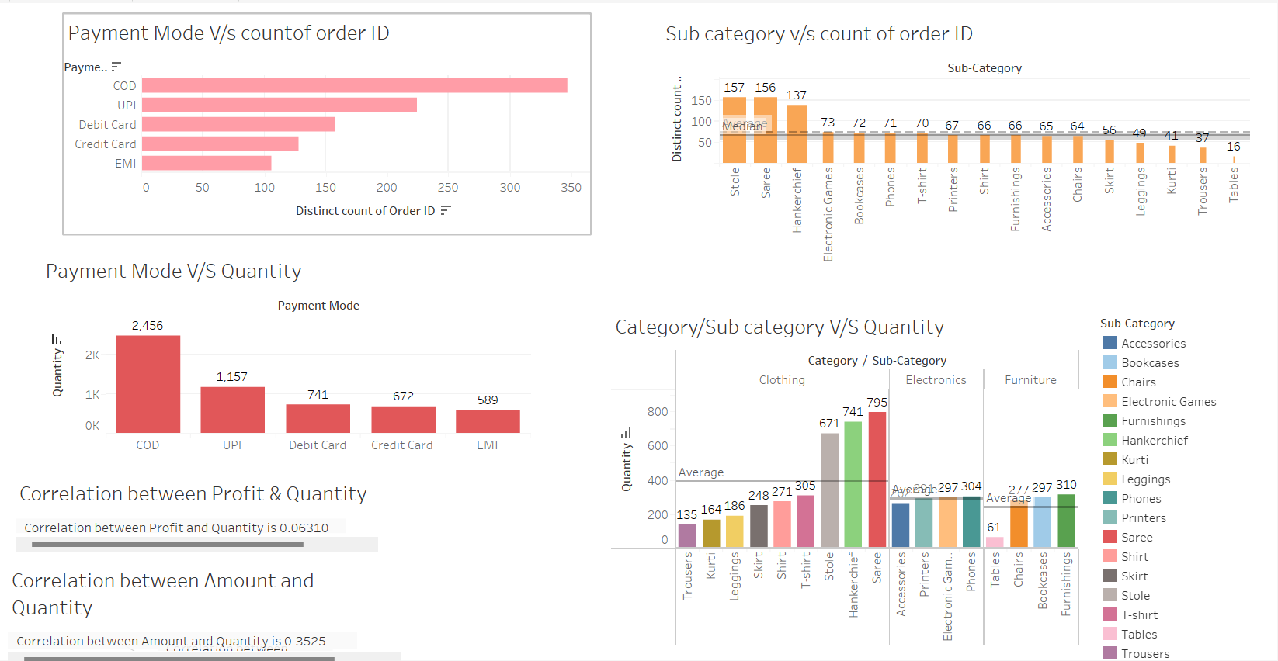

Correlation between Profit & Quantity and between Amount & Quantity is extremely low. Maximum number of orders are made for Stole, Saree, handkerchief. Minimum number of orders are made for tables, trousers, kurti, and leggings.

**Major Inferences:**

* Payment for maximum number of orders has occurred through COD mode of payment.
* Maximum number of orders have been placed for Stole, immediately followed by Saree. Lowest number of orders have been placed for Tables. Average number of orders is 74.
* Highest profit % of the total is for Clothing category, closely followed by Electronics category.
* The total profit for Saree (clothing category), printers (electronic category) and Bookcases (furniture category) is highest. There are few subcategories such as leggings, Skirt, kurti (clothing category); electronic games (Electronics category); and furnishings (furniture category) that have incurred losses.
* Sarees, Phones and Furnishings have the highest no. of quantity sold in each of the three categories.
* Correlation between Profit & Quantity and between Amount & Quantity is extremely low.
* Correlation between Amount and Profit is extemely low.

**Tableau Public link:**

[**https://public.tableau.com/views/TopMentor_26thMarh_2023_AdvancedWeek1_Details/MainDashboard?:language=en-US&publish=yes&:display_count=n&:origin=viz_share_link**](https://public.tableau.com/views/TopMentor_26thMarh_2023_AdvancedWeek1_Details/MainDashboard?:language=en-US&publish=yes&:display_count=n&:origin=viz_share_link)